**Lab #4**

Alexander Bartella (400308868), in collaboration with Jacqueline Leung

**MAGNETIC FORCES**

This experiment is divided into two parts, both of which will be completed in one laboratory session.

**Introduction:**

In Part A, a cathode ray tube and a pair of Helmholtz coils are used to deflect an electron beam in a magnetic field. This apparatus reproduces one version of J.J. Thomson's famous experiment, providing an accurate measurement of the charge-to-mass ratio (e/m) of the electron. The aim of our experiment is to study the functional dependencies of the electron path on both electron velocity and magnetic field amplitude and to obtain an experimental value for e/m.

In Part B, you will measure the magnetic force due to current flow in parallel wires (rods). The force will

be compared to theoretical values and the permeability of free space (µ0) will be found from this data.

**PART A: Electron Ballistics in a Magnetic Field (Measurement of e/m)**

The apparatus consists of a large CRT which is mounted between a pair of “Helmholtz coils”. The tube contains an electron gun, which generates a focused beam of electrons. It is filled with a trace amount of helium giving the electron beam a blue-green hue. A measured accelerating potential (V) is applied to the electron gun. This defines the velocity of electrons impinging on the CRT screen. The Helmholtz coils provide a magnetic field which is used to deflect the electron beam in the CRT. A measured current is applied to the Helmholtz coils so that the magnitude of the magnetic field within the electron tube can be calculated. The magnetic field (B) deflects the electron beam from its normally straight path into a cylindrical helix path. In the plane perpendicular to the magnetic field, the electrons travel in a circular path with radius (r) that can be measured on the CRT screen. From these measured values, the charge-to-mass ratio of the electron can be obtained as:

e/m = 2V / B2r2 (1)

**Experimental Procedure**

Before wiring, position all power supplies and meters on your bench at least one diameter away from the

Helmholtz-coil to avoid disturbing its magnetic field.

Connect the power supplies and meters to the apparatus as in Fig. 1 and 2. **Use the digital handheld meter to measure the current through the Helmholtz coil and the digital benchtop meter to measure the accelerating voltage.** You may optionally adjust coil current at the supply, or at the “CURRENT ADJ” control on the apparatus.

First, apply about one ampere of coil current so that when an electron beam is established, it won't hit

(and overheat) the tube's glass envelope. Turn on the filament/high voltage supply. Electrons need at least

100 V accelerating voltage to overcome gas collisions, and complete their arc in the magnetic field.

Observe the following limits:

• 100V < accelerating voltage < 300V

• 0A < Helmholtz-coil current < 2A

The tube containing the electron gun is mounted on a rotatable fixture. Rotate the tube base so that the

electron beam completes its arc onto the backside of the electron gun. The plane of the beam should now be perpendicular to the magnetic field. Establish the ranges of accelerating voltage and coil current that give measurable radii.

Take radius data (at least 6 data points each) for:

1. Fixed coil current, multiple accelerating voltages

2. Fixed accelerating voltage, multiple coil currents

Take care to eliminate parallax errors when measuring the beam radius. Move your head so that the electron beam, its reflection from the glass scale, and your eye reflection all line up.

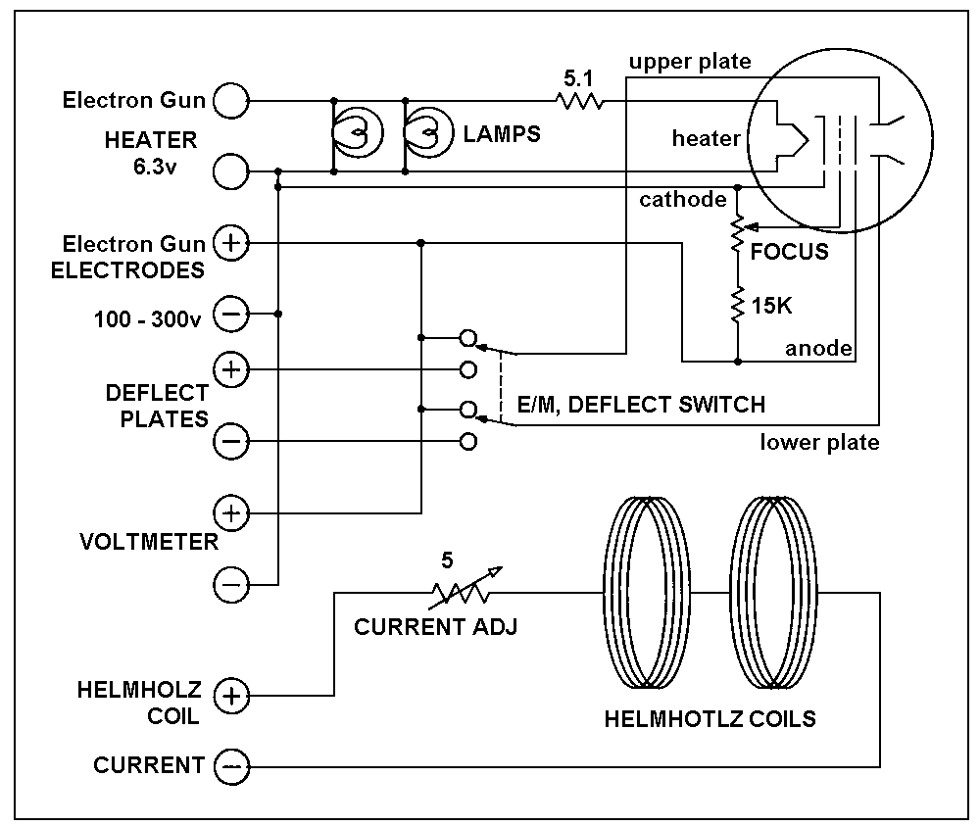With supplies adjusted for a small beam radius, carefully rotate the glass tube base to various angles, observing the electron path. Make a note of the behavior. Do not grasp the tube by its glass bulb.

Fig.1 - Pasco e/m apparatus wiring diagram.

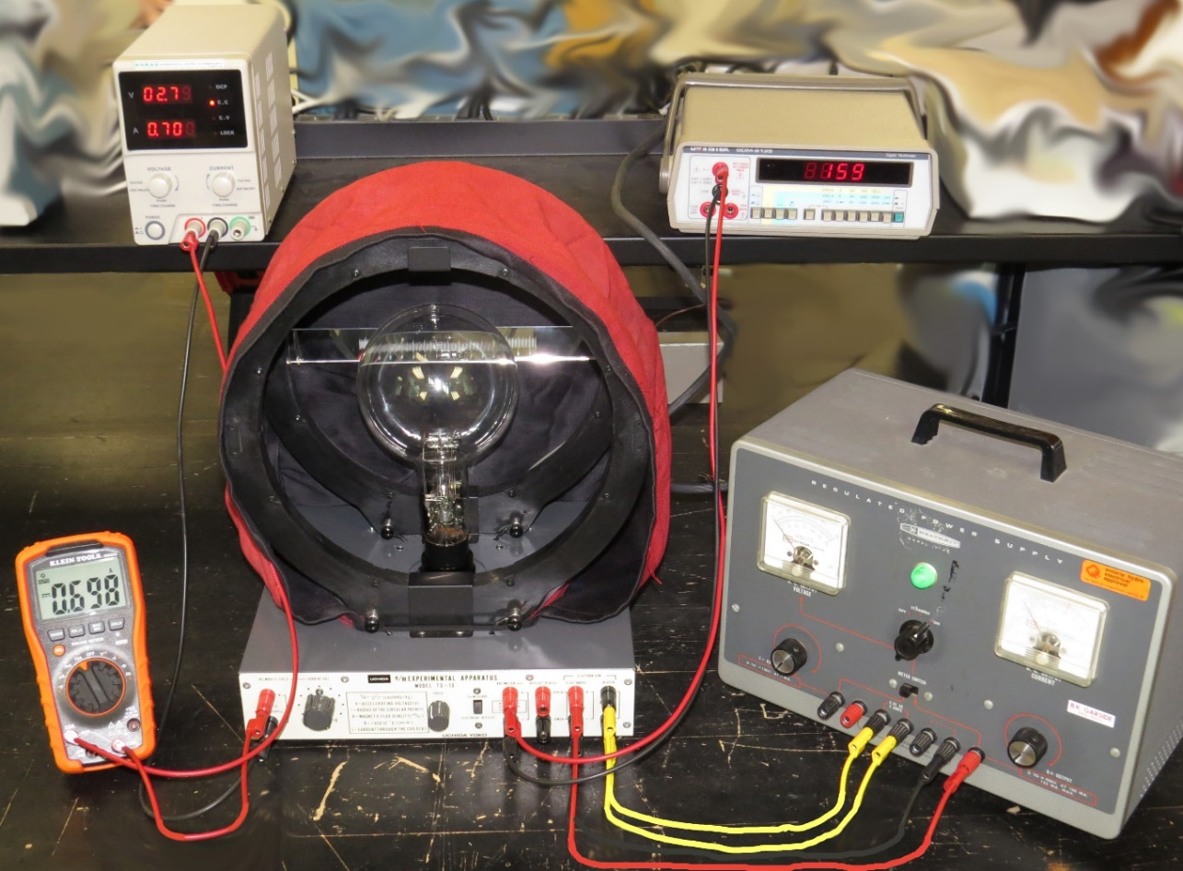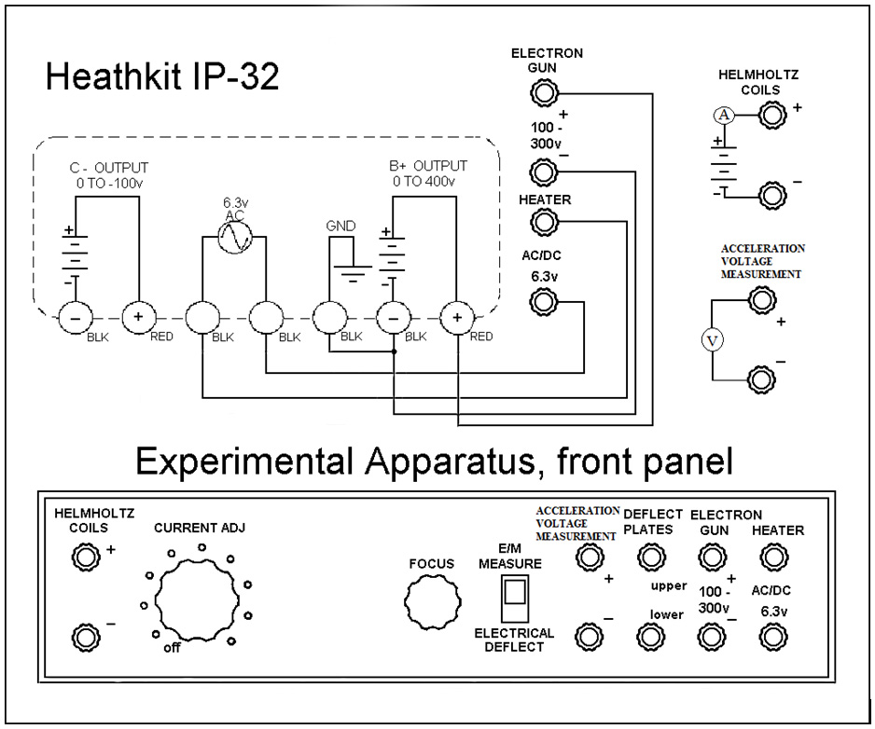

Fig.2 - High voltage power supply connections and Pasco e/m apparatus front panel.

**Collected Data for Part 1:**

**Table A1: Equipment Uncertainties**

|  |  |
| --- | --- |
| **Instrument** | **Uncertainty** |
| Benchtop Voltmeter | ± 0.2% |
| Handheld voltmeter | ± 1.5% |
| Ruler | ± 0.05 cm |

**Table A2: Measurements for change in magnetic ring radius by varying accelerating voltage and fixed Coil current.**

In this part of experiment the coil current was kept constant and the accelerating voltage was varied for every new reading.

**Fixed Coil Current= *Ic* =** 1.800 A

|  |  |
| --- | --- |
| **Fixed Coil Current= Ic =** 1.800 **A** | |
| **Accelerating Voltage (VA±0.2% V)** | **Radius of Magnetic Ring (cm) (r ± 0.05cm)** |
| 130 | 1.6 |
| 148 | 1.8 |
| 180 | 2.0 |
| 207 | 2.2 |
| 278 | 2.6 |
| 301 | 2.8 |
|  |  |
|  |  |

**Table A3: Measurements for change in Magnetic ring radius by varying coil current and fixed accelerating voltage.**

**Fixed accelerating voltage = *Vac* =**

|  |  |
| --- | --- |
| **Fixed accelerating voltage = *Vac* =** | |
| **Coil current (Ic± 1.5% A)** | **Radius of Magnetic Ring (cm) (r ± 0.05cm)** |
| 1.988 | 1.5 |
| 1.693 | 1.8 |
| 1.559 | 2 |
| 1.425 | 2.2 |
| 1.259 | 2.5 |
| 1.176 | 2.6 |
| 1.064 | 3 |
| 0.972 | 3.1 |

**PART A: Electron Ballistics in a Magnetic Field (Measurement of e/m)**

**Questions to be Answered for Your Report**

**Q1:** Derive equation 1: e/m = 2V/B2r2 **(3 mark)**.

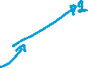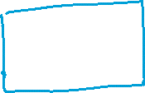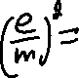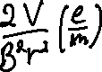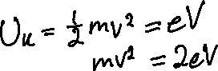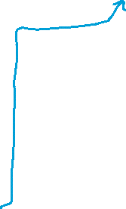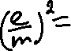

**Q2:** Derive, from first principles, the magnetic field along the axis between the two coils as a function of distance between the coils **(Derivation: 4 marks)**. Evaluate this equation to find the magnetic field at the center of the coils **(2 mark).** Leave all the terms. **(6 marks in total)**

**Q3:** Plot a graph, with uncertainties, of:

* 1. “radius vs. ” for the fixed current data – **(3 marks; 1.5 marks for the theoretical curve and 1.5 marks for the experimental curve; and -0.5 for each missing error bar)**.

**Error bars are present, but are very small

* 1. “radius vs. 1/magnetic field (field at the center of the coils)” for the fixed accelerating voltage data – **(3 marks: 1.5 marks for the theoretical curve and 1.5 marks for the experimental curve; and -0.5 for each missing error bar)**.

**Q4:** Extract a value for e/m from the plot of radius vs. . Compare it to the accepted value **(2 mark).**

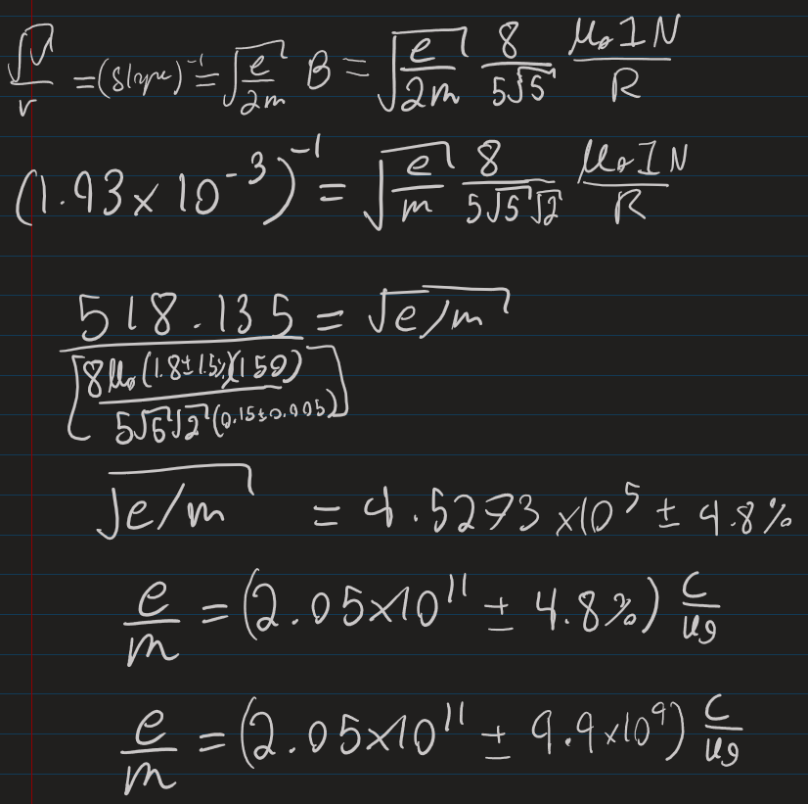

**Q5:** Compare the experimental values for e/m to the accepted value and discuss whether they agree within the uncertainty of the experiment **(2 mark).**

The acquired value for e/m is similar to the accepted value. However the accepted value, 1.76E+11, is not within error bounds of the experimental value, . So, it can be said that the values do not agree within uncertainty. This may be due to factors of uncertainty that are not accounted for in the calculation of e/m, such as sources of error from the calculation of the slope, and from possible electromagnetic interference in the room.

**Q6:** How does the electron beam radius relate to the electron velocity and to 1/magnetic field? **(2 mark)**

Observing the derivation on the left from question 3 part B, it can be observed that the electron beam radius and , are related linearly. Because of this, it can be said that the two variables are proportional to one another, which also means that B is inversely proportional to r.

**Q7:** Discuss at least three possible systematic reasons for a deviation of experimental data from the theoretical curves **(3 marks in total; 1 mark for each valid reason)**.

Systematic causes of error surrounding the experiment could be causing a deviation from the theoretical curves. An assumption that was made was that there were no imperfections on the surface of the coils (1). This would cause slight variances between the measured and theoretical values. Another assumption was that the coils are perfectly parallel about the axis through their center (2), and that the coils are perfectly circular (3). It is possible that if the coil apparatus were heavily used for previous labs, that the coils could be warped due to heat and wear over time, causing the radius to vary over the length of the coil. If this were the case, then additional error would be present because the varying radius was not accounted for. Finally, it is possible that the distance between the coils was not exactly equal to the radius of the coils, or that either coil had a slightly different radius, causing the point of interest not to be equal to R/2.

**Q8:** Describe the qualitatively the electron path when not perpendicular to the magnetic field vector. Explain this phenomenon theoretically **(2 mark)**.

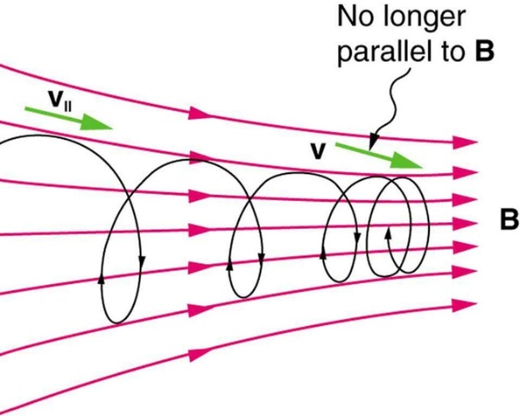

The electron path not perpendicular to the magnetic field vector would be caused by the velocity vector not being perpendicular to the magnetic field (or, where one component of the velocity vector is not perpendicular to the magnetic field). This would cause the path of the electron to be helical and narrowing. In other words, the position of the electron will vary on the x-axis (axis between the coils), instead of only the y and z axis.

Diagram of Helical motion of a particle

**Q9:**  Reflect on the key components of this lab and its applicability**. (2 marks)**

­Helmholtz coils are commonly used to measure the strength of bar magnets, and ere also used to measure the charge to mass ratio of electrons, such as observed above with the derivation of e/m. Helmholtz coils are also used during laboratory experiments done in a vacuum to cancel the effect of the earth’s magnetic field, as also observed above. This allows laboratory experiments to happen with close to truly neutral conditions.

**PART B : MAGNETIC FORCE (AMPERE'S LAW)**

In Part B, a sensitive balance is used to investigate the force between two current carrying wires. From the data, the permeability of free space will be found.

**Introduction**

The force between two parallel current-carrying rods is given by (see Appendix 4A): F = oli2 / 2d (1)

F = force between rods, Newtons l = length of rods, metres

i = current in rods, Amps

d = separation between rods, metres

o = permeability of free space = 4 x 10-7 Newtons / Amp2

You will use Eq. (1) and an apparatus of current-carrying parallel rods to find the permeability of free space o. The longer current-carrying rod is fixed to the baseplate and does not move, although its height is independently adjustable at each end. The other rod is suspended above the fixed rod on a cantilevered arm. The arm length is long enough that the upper rod traces a large arc that is almost linearly vertical for small motions above the fixed rod. Current is fed to the upper rod through the cantilever arm, and through the knife edges upon which it sits. Current through the arms does not contribute to the force because it flows at right angles to both rods.

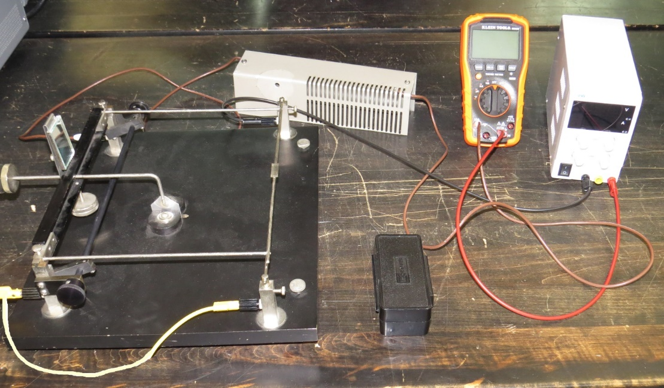

Fig. 1. Experimental apparatus.

Two counterweights on threaded rods allow the position and sensitivity (stability) to be adjusted. A reflecting mirror is fixed to the arm so that small deflections of the upper rod will tilt the mirror. A scale, mounted on the telescope stand, is reflected by the mirror into the telescope. If it is placed at a sufficient distance (1-2 meters) from the mirror, deflections of less than 0.05 mm can be seen.

A small pan is attached to the top of the upper rod into which small weights are placed, causing the rod to drop down toward the lower one. The weights will be staples with a weight of 32.2 mg +/- 10% each. These staples can be cut in half. Current flowing in the rods generates a counteracting force. Current may be adjusted to bring the upper rod back to its initial position before the weight was added. Referring to equation 2, by changing weights and starting position, force can be shown to vary proportionally to i2 and inversely with d. The permeability of free space can also be measured.

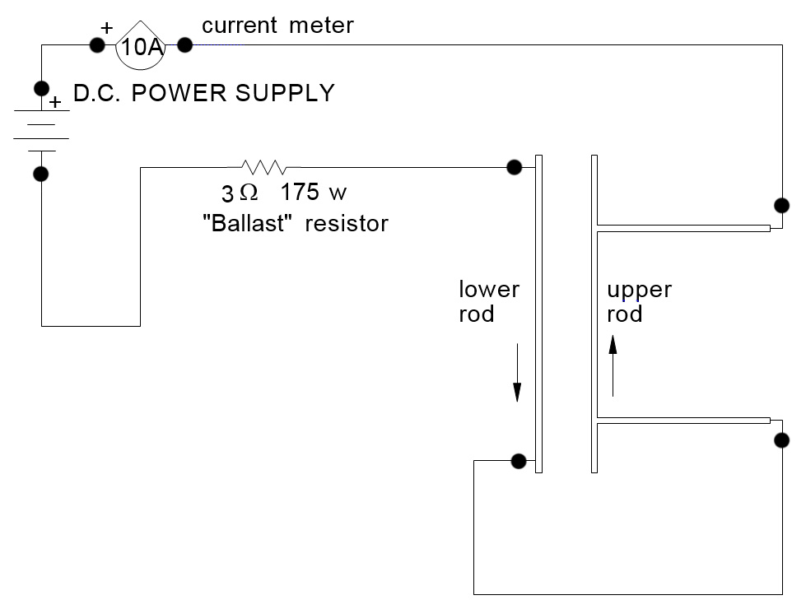**Experimental Procedure**

Fig. 2. Experimental setup.

The two pivot points on which the cantilevered arm sits are precision ground knife edges that cannot take rough handling. **USE THE BAIL WHENEVER LIFTING OR LOWERING THE KNIFE-EDGES ONTO THEIR BEARING SURFACES**. All positioning adjustments, counterweight adjustments and mirror adjustments must be done with the bail taking the load, not the knife-edges.

Set up the telescope/scale at one end of the bench, and the apparatus baseplate at the other end. Adjust the screws supporting the baseplate so that is don’t rock. Align and focus the telescope - only a small

section of the scale will be visible in the mirror.

Adjust the counterweight at the rear so that the upper rod floats 4 - 5 mm above the lower rod (with no weights in the pan). Try your best to make sure the lower rod is linearly vertical to the upper rod by adjusting its position. Remember to use the bail when making adjustments.

Connect the power source through a 10 A range of the digital handheld meter to the binding posts on the apparatus. These wires generate magnetic fields that could influence your results. You can reduce the interference in two ways:

(a) A twisted pair of wires carrying current in opposite directions generates minimal fields.

(b) Wires oriented at right angles to the rods have field vectors which do not contribute to the force between the rods.

Apply current, checking that you get an upward deflection.

Using the telescope/scale, take note of the rod position (p1) with no current. Load the upper rod with a weight of your choosing, adjusting current to bring the rod back to p1. Note the current. Measure this again with the current direction reversed. Any differences between forward and reverse current are likely due to the earth's magnetic field, so average your two current values to help reduce this effect. Measure this for two different weights per group member. Keep current below 8 amps, and only for short periods of time to avoid overheating. Load the upper rod with enough weight so that it rests against the lower rod. Measure its position p2.

Your scale readings can be converted to real distances using the same principle as in lab 2 (see Appendix

2C). Make sure you have the following data:

• distance from mirror to scale

• distance from knife-edges to center of the rod

• rod diameter

• rod length (shorter rod)

• error of ammeter

**Collected Data for Part B:**

**Table B1: Equipment Uncertainties**

|  |  |
| --- | --- |
| **Instrument** | **Uncertainty** |
| Ruler | ± 0.05 cm |
| Handheld voltmeter | ± 1.5% |
| Vernier Caliper | ± 0.01 mm |
| Error related to telescope (estimated) | ± 0.05 cm |

**Table B2: Important distances**

|  |  |
| --- | --- |
| **Instrument** | **Uncertainty** |
| Distance from mirror to scale | 150.0 cm ± 0.5 mm |
| Distance from knife-edge to center of the rod | 21.5 cm ± 0.5 mm |
| Rod length | 29 cm ± 0.5mm |
| Rod diameter | 3.68 mm ± 0.01 mm |

**Table B3: Measured parallel plate deflection due to weights and currents:**

|  |  |  |  |
| --- | --- | --- | --- |
| **Mass (mg)** | **Telescope reading (mm)** | **Current (A)** | **Reverse Current (A)** |
| 0 | 17 | 0 | 0 |
| 12.5 | 17.7 | 5.5 | 5.47 |
| 25 | 18.5 | 7.98 | 7.98 |
| 31.25 | 18.9 | 9.01 | 9.01 |
|  |  |  |  |

**Weight on which the rod touch =** 43.75 mg

**Scale reading for rod touching =** 19.6 mg

**Questions to be Answered for Your Report**

Q1: Show from the experimental data that the magnetic force is proportional to i2 using a plot. **(3 marks; -0.5 for missing error bars)**.

**Q2:** Extract a value for μo from your plot with complete error analysis **(1 mark for µ0 value and 1 mark for error calculation)**. Compare your result to the theoretical value and discuss any possible sources of error **(2 marks). ( 3 marks in total)**

The derived value, , is very similar to the accepted value, . While the values are similar, the accepted value is not within the error bounds of the acquired value. This is because of unaccounted-for errors discussed previously, such as the error that occurred during the calculation of the slope, and possible interference.

**Q3**: Roughly calculate the magnetic field (B), between the rods, for one of the data points. **(3 marks for the derivation of the equation from first principles; -2 for no derivation; 1 mark for error calculation).**

**Q4:** Compare the amplitude of the magnetic field between the rods (from above question) to the amplitude for the Earth s magnetic field - find the value of Earth magnetic field in literature and provide a valid reference, also explain is the earth’s magnetic field a large source of error? What other magnetic fields sources could be affecting your data **(3 mark).**

The magnetic field of the Earth, , is much smaller than the magnetic field observed between the rods, . The experimental value between the rods is much greater, meaning the force caused by the magnetic field of the rods is higher in magnitude as well. Considering the experiment, the magnetic field of the earth is a large source of error. When taking measurements, the magnetic field of earth could have contributed or removed (depending on the direction vectors of each field) a maximum of from the field produced by the wires. Therefore, when accounting for the magnetic field of Earth, the error in the acquired field is therefore , where the uncertainty is much larger than previous. Other, very small sources of magnetic field could be influencing the results, such as electrical appliances in the surrounding area and measurement instruments.

Source:

J. Espinosa, J. Pérez, J. J. Miret, M. T. Caballero, C. Vàzquez, D. Mas, C. Hernandez, and C. Illueca, “Earth's magnetic field,” *BLENDED LEARNING LABS PRACTICE. MAGNETIC FIELD MEASUREMENT*. [Online]. Available: https://web.ua.es/docivis/magnet/earths_magnetic_field2.html#:~:text=The%20strength%20of%20the%20field,and%20in%20part%20of%20Siberia. [Accessed: 22-Mar-2022].

**Q5:** Compare the experimental value for µ0 to the accepted value and discuss whether they agree within the uncertainty of the experiment. Also, Discuss at least two possible reasons for differences between the experimental value of µ0 and the accepted value (assumptions and errors? **(3 mark)**.

The derived value and the accepted value are very close in value. Despite this, they are not within uncertainty of each other. This is because of unaccounted-for errors discussed previously. For example, the uncertainty caused by the Earth’s field is not accounted for in the calculation of field, and there are other sources of electric and magnetic fields in the surrounding area that could be causing this discrepancy, such as instruments and electronic appliances nearby. In addition, the precision of the instruments used to measure the acquired data may be imprecise, causing increased error in the values used to calculate . Another possible error is due to the assumption that the two rods remain perfectly parallel through the entire experiment, and that there are no imperfections in their surfaces.

**Q6:** Reflect on the key components of this lab and its applicability. (2 mark)

During this lab I learned about the properties of Biot-Savart law. This concept is used in the design of magnets. Biot-Savart law plays a large role in the design of shielding for current-carrying wires, preventing the constructive and destructive interference of two current-carrying wires in environments such electrical infrastructure like power lines where current is high. This lab also serves to provide experience comparing and graphing results, and deriving formula from first principles: deepening one’s understanding of the origin of the equations we use often throughout this course.

**APPENDIX 4A: Force between Current Carrying Rods**

The SI system of measurement gives the ampere the following definition: *"One ampere is that unvarying current which, if present in each of two parallel conductors of infinite length and one meter apart in empty space, causes each conductor to experience a force of 2 x 10-7 newton per meter of length".*

This definition can be obtained directly from the inverse-square law:

dF = (o / 4r2) i1i2 sin dl1dl2 (1)

μo is the permeability of free space (vacuum) defined to be 4π x 10-7 N/A2; F is in Newtons; i1 and i2 are in

Amperes; *1*, *r* are in meters

dl 1

i 1

r

i 2

  

dl 2

d

Fig. 1. Parallel rods.

The geometry of the apparatus used in this experiment is very similar to that defining the Ampere. A known current passes through two parallel rods in opposite directions and the force of repulsion is measured.

The total force is obtained by integrating Eq. (1). To simplify the integration, the rod carrying current i1

will be set to be infinitely long when finding the force on current element i2 and vice-versa.

This means that the rod separation must be a small fraction of rod length in an effort to reduce a source of systematic error in the experiment. Under this condition, Eq. (1) reduces to:

F = oli2 / 2d (2)

F = force between rods, Newtons l = length of rods, metres

i = current in rods, Amps

d = separation between rods, metres

o = permeability of free space = 4 x 10-7 Newtons / Amp2